**Practical No – 10**

**Aim :** Data discretization.

**Solution :**

In ‘Filters’ window, click on the ‘Choose’ button.

This will show pull-down menu with a list of available filters. Select Supervised 🡪Attribute 🡪

Discretize and click on ‘Apply’ button.

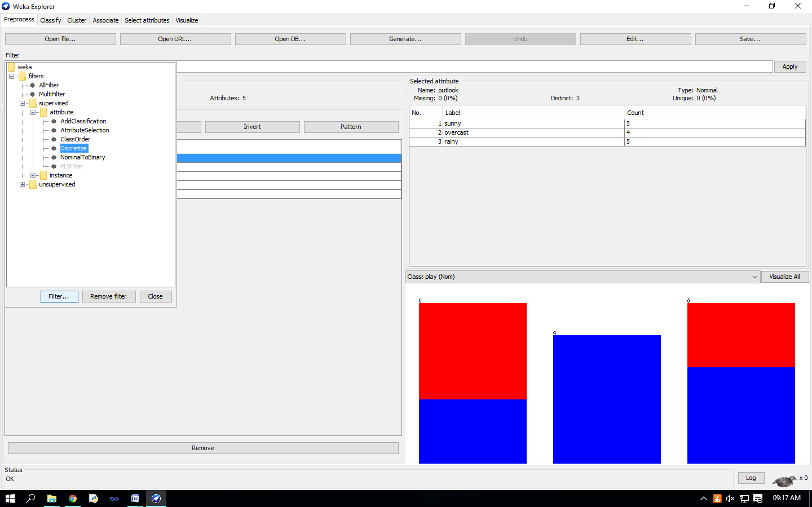 The filter will convert Numeric values into Nominal.

the fields in the window changes to reflect available options.

